The Journal of Pediatric & Neonatal Research
About the Journal:
The Journal of Pediatric & Neonatal Research (JPNR) is an international, peer-reviewed scientific platform dedicated to advancing research in pediatric medicine, neonatal care, and child health development. The journal publishes original research articles, clinical studies, reviews, and emerging discoveries covering the full spectrum of pediatric and neonatal health, including neonatal physiology, infant nutrition, childhood diseases, developmental pediatrics, pediatric immunology, infectious diseases in children, and therapeutic innovations for newborns and pediatric patients. JPNR provides a multidisciplinary forum that encompasses research on growth and development, pediatric surgery, pediatric cardiology, neonatal intensive care, pediatric oncology, metabolic disorders in children, and evidence-based clinical practices that improve outcomes for vulnerable pediatric and neonatal populations.
The journal serves as a comprehensive platform for pediatricians, neonatologists, researchers, clinicians, nurses, and healthcare professionals to explore advances in pediatric science, including newborn screening, early childhood interventions, infectious disease prevention, chronic disease management in children, and regenerative medicine approaches for pediatric conditions. JPNR aims to promote scientific collaboration, translate cutting-edge pediatric and neonatal research into improved clinical practice, and advance the health and well-being of children from birth through adolescence. By fostering dialogue between academic researchers, clinical practitioners, and healthcare policymakers, the journal contributes to the translation of evidence-based research into actionable strategies that enhance pediatric care quality, improve neonatal survival rates, reduce childhood morbidity and mortality, and promote healthy development and optimal outcomes for children globally.

Latest News:
Smartphone acquisition and insufficient sleep in adolescents
Smartphones have become the primary type of recreational screen use among adolescents. In an observational cohort study of 1959 adolescents with no smartphone at age 13 years, subsequent smartphone acquisition was associated with insufficient sleep at age 14 years; this risk was mitigated by leaving the smartphone outside the bedroom. Smartphone use for more than five hours/day was also associated with increased rates of depression and obesity. These observations expand on prior evidence that links screen use with depression, obesity, and decreased sleep duration in adolescents.


Trends in smoking and nicotine product use among United States youth
New data from the National Youth Tobacco Survey (NYTS) show ongoing declines in smoking, vaping, and other forms of tobacco use among middle school and high school youth in the United States. However, despite the overall declines, concerning trends among those who report tobacco use include an increase in the intensity of vaping (daily use) from 9 to 35 percent and the doubling of nicotine pouch use. In addition, more than three-quarters of youth who vape used flavored products, which are known to appeal to novice users. This raises concerns about the 2026 changes in Federal regulations, which weakened restrictions on flavored nicotine products. These findings call for ongoing vigilance by primary care clinicians for all types of nicotine use among youth, and advocacy to support robust State- and Federal-level tobacco regulation, especially of flavored products.


Return to play after surgery for capitellar osteochondritis dissecans
Published evidence about outcomes and rates of return to sport for patients with capitellar osteochondritis dissecans is limited. In a recent systematic review of 16 observational studies involving 389 youth baseball players with capitellar osteochondritis dissecans, 92 percent were able to return to play following operative management; however, 29 of 60 pitchers could not return to pitching. Autologous osteochondral transplantation was the most common procedure. Large heterogeneity among studies precluded comparison among surgical techniques.
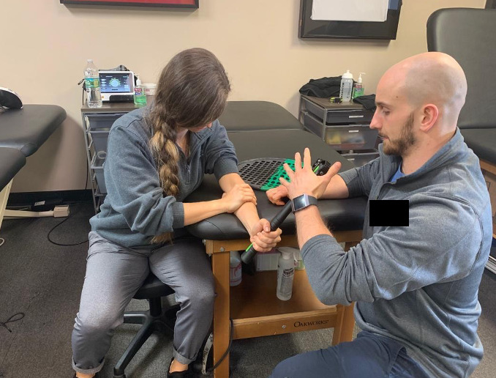

Caregivers' concerns about vaccine safety and sources of misinformation
Caregiver concerns about vaccine safety are a significant cause of vaccine exemption requests. These concerns are intensified by negative word of mouth or media messages, which may be based on results of methodologically flawed studies that have reported associations between vaccines and certain conditions despite a lack of evidence to support these claims. Recently, studies that previously reported associations between vaccination and adverse outcomes have been retracted or are under investigation due to concerns about their statistical methods and the validity of their results, including those related to sudden infant death syndrome; autism spectrum disorder; and asthma, ear infections, and developmental delays. It is important for clinicians to be aware of misinformation about vaccines so they can address caregiver concerns effectively.
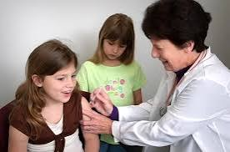

Scientific Topics
1. General Pediatrics
Research covering the diagnosis, treatment, prevention, and management of diseases and health conditions affecting infants, children, and adolescents.
2. Neonatology & Newborn Care
Research focused on newborn health, neonatal diseases, early-life care, and advances aimed at improving neonatal survival and outcomes.
3. Neonatal Intensive Care
Studies involving critically ill newborns, respiratory support, neonatal monitoring, infection management, nutrition, and intensive care practices.
4. Pediatric Critical Care & Emergency Medicine
Research on acute and life-threatening conditions in children, including resuscitation, trauma, emergency care, intensive care, and clinical outcomes.
5. Pediatric Infectious Diseases
Research on infectious diseases affecting children and newborns, including diagnosis, treatment, prevention, antimicrobial therapy, and vaccination.
6. Pediatric Cardiology
Studies covering congenital and acquired heart diseases in children and neonates, including diagnosis, cardiac imaging, interventions, surgery, and outcomes.
7. Pediatric Neurology & Neurodevelopment
Research on neurological and developmental disorders in children, including epilepsy, neurodevelopmental disorders, neuromuscular conditions, and brain development.
8. Pediatric Oncology & Hematology
Research on childhood cancers, blood disorders, diagnosis, treatment, supportive care, novel therapies, and long-term outcomes.
9. Pediatric Gastroenterology & Nutrition
Studies addressing gastrointestinal, liver, feeding, and nutritional disorders in children and infants, including malnutrition and nutritional interventions.
10. Pediatric Endocrinology & Metabolism
Research involving childhood diabetes, growth disorders, thyroid disease, obesity, puberty, and inherited or acquired metabolic disorders.
11. Pediatric Respiratory Medicine
Research on respiratory diseases in children and neonates, including asthma, respiratory infections, neonatal respiratory disorders, and chronic lung conditions.
12. Pediatric Genetics & Genomic Medicine
Research on genetic disorders, genomic medicine, genetic diagnosis, inherited diseases, and emerging applications of precision medicine in pediatric and neonatal care.
13. Pediatric Surgery & Perinatal Medicine
Research covering surgical conditions in children and newborns, congenital abnormalities, fetal and perinatal medicine, and advances in surgical and perinatal care.
14. Child Growth, Development & Adolescent Health
Studies addressing physical, cognitive, behavioral, and emotional development from infancy through adolescence, including adolescent health and preventive care.
15. Pediatric Clinical & Translational Research
Clinical studies, clinical trials, biomarkers, innovative diagnostic approaches, and translational research that contribute to improved pediatric and neonatal healthcare.

